READING 1
Passage 1
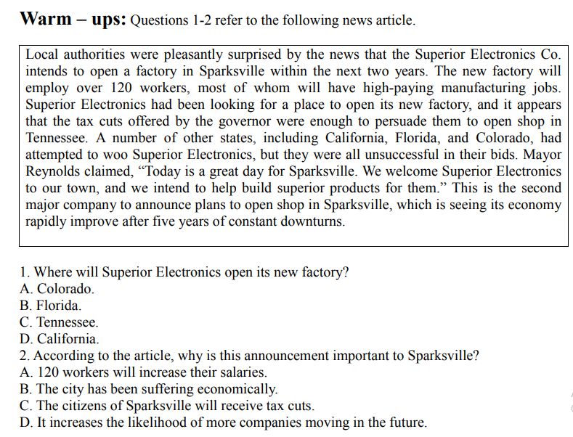

Passage 2

Passage 3
Flying tortoises
An airborne reintroduction programme has helped conservationists take significant steps to protect the endangered Galapagos tortoise.

On Galapagos island, only the thick vegetation at the skirt of the peak of Sierra Negra offers accommodation for animals. This difficult environment is home to the giant Galapagos tortoise. Around five million years ago, many tortoises started to live on the island. The different populations adapted to their unique environments, giving rise to at least 14 different subspecies. Island life agreed with them. In the absence of predators, they grew to become the largest tortoises on the planet, weighing more than 400 kilograms, occasionally exceeding 1.8 metres in length and living for more than a century.

Before human arrival, the tortoises numbered in the hundreds of thousands. From the 17th century onwards, pirates took a few on board for food, but the arrival of whaling ships in the 1790s saw this exploitation grow strongly. Relatively immobile and capable of surviving for months without food or water, the tortoises were taken on board these ships to act as food supplies during long ocean passages. Sometimes, their bodies were processed into high-grade oil. In total, an estimated 200,000 animals were taken from the island before the 20th century. When settlers came to the islands, the number of tortoises even reduced more strongly. They hunted the tortoises and destroyed their habitat to clear land for agriculture.
Today, only 11 of more than the 20 original subspecies survive and of these, several are highly endangered. In 1989, work began on a tortoise-breeding centre just outside the town on the island, dedicated to protecting the island’s tortoise populations. The project is to save the tortoises’ population.
The problem was also a pressing one. Captive-bred tortoises can’t be reintroduced into the wild until they’re at least five years old and weigh at least 4.5 kilograms, at which point their size and weight are sufficient to protect them from predators. But if people wait too long after that point, the tortoises eventually become too large to transport.

For years, repatriation efforts were carried out in small numbers, with the tortoises carried on the backs of men over weeks of long, treacherous hikes along narrow trails. But in November 2010, the environmentalist and Galapagos National Park liaison officer Godfrey Merlin, a motor yacht captain and a helicopter pilot gathered around a table in a small café in Puerto Ayora on the island of Santa Cruz to work out more ambitious reintroduction. The aim was to use a helicopter to move 300 of the breeding centre’s tortoise to various locations close to Sierra Negra.

This effort was made possible by the owners of the 67 – metre yacht White Cloud, who provided the Galapagos National Park with free use of their helicopter and its experienced pilot, as well as the logistical support of the yacht, its captain and crew. The yacht’s helicopter has a rear double door and a large internal space that’s well suited for cargo, so a wooden box was designed to hold up to 30 tortoises with a total weight of about 150 kilograms. During a period of three days, a group of volunteers from the breeding centre worked around the clock to prepare the young tortoises for transport. Meanwhile, park wardens, prepared time in remote locations, cleared landing sites within the thick brush, cacti and lava rocks.

Upon their release, the small tortoises quickly spread out over their ancestral territory, investigating their new surroundings and feeding on the vegetation. Eventually, one tiny tortoise came across a fully grown giant who had been living around the island for around a hundred years. The two stood side by side, a powerful symbol of the regeneration of an ancient species.

1. What is the main title of the first paragraph?
A. An increase in the number of tortoises
B. The threat of tortoises
C. The arrival of settlers
D. Volcanic activities
2. Why is the number of tortoises on the island decreasing?
A. Due to the epidemic
B. Due to the migration of turtles
C. Due to overexploitation
D. Due to volcanic eruption
3. How many subspecies of turtles exist?
A. 10
B. 11
C. 12
D. 20
4. What important factors influence the movement of tortoises?
A. Age and weight
B. Gender and age
C. Gender and weight
D. Age and subspecies
5. What does the last paragraph refer to?
A. Hope for the growth of tortoises again
B. Worry about disease
C. Gender imbalance
D. Worry about predators

Passage 4





READING 1: ANSWER
- Passage 1
- C
- B
- Passage 2
- C
- B
- Passage 3
- A
- C
- B
- A
- A
- Passage 4
- D
- A
- D
- B
- C
- B
- A
- D
- C
- C

